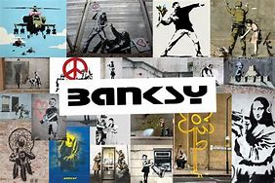

BANKSY – Topic Work 25.03.2020

About Banksy

Banksy is an anonymous street artist , originally from Bristol, England. He is what is known as a political activist.
When he started out he was inspired by another graffiti artist called 3D.
When Banksy first started he was a freehand, he did this from 1990 until 1994.
Then he met a photographer called Steve Lazarides who began selling his art for him and later became his agent, this means he was like his manager.

The Rat

I think that the piece of work of the rat symbolises the press and media and that they are vermin who can be not very nice people.

SHOREDITCH

I think this picture symbolises that older people and young people should be treated equally and not to think all old people are boring.

SHOP TILL YOU DROP

I think this picture is about being greedy and that we shop too much and spend too much money.

CHAMBER MAID IN HOXTON

I think this is about sweeping problems in the world under the carpet, especially people being poor and rich people beingh mean and greedy.

MY THOUGHTS ON BANKSY

I thinks Banksy is a nice man or lady who tries to show people what is correct in the world even if not everyione agrees. He gives out powerful messages.

Banksy £10 NOTE

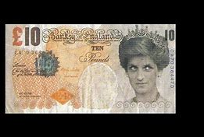

These are the fake ten pound notes Banksy made, they were saying that Princess Diana was actually the Queen I think. These notes sell for around £700 each, which is a lot of money!

BANKSYS MOST EXPENSIVE PIECE

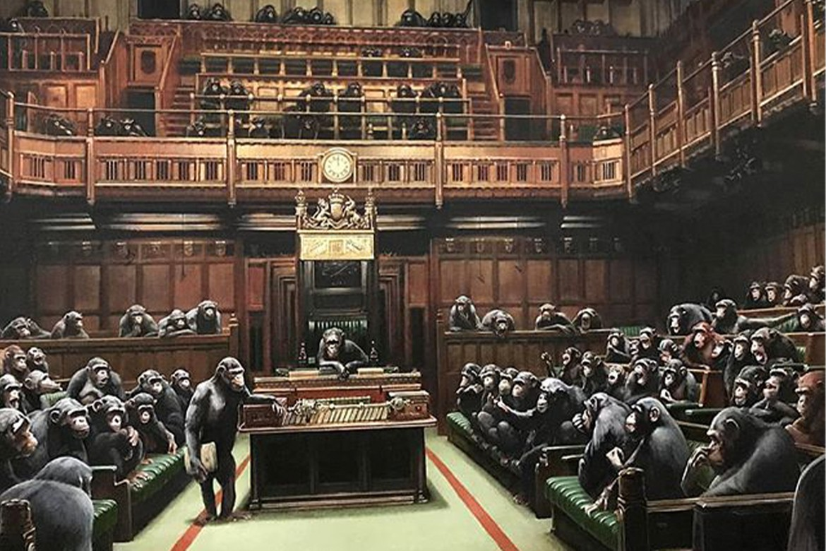

This is called “Devolved Parliament” and is a picture of chimps in parliament running the country. This is the most expensive piece so far and was sold for $12.2m .

Counterfeit Money

Counterfeit money is fake money, like the ones that Banksy made. There are 566,000 notes on average in the UK.

My PIECE OF GRAFFITI



