Greece/Ancient Greece Choosing Grid: Week 3
Our whole-school theme for this half-term will focus on learning about Greece/Ancient Greece. Each week you will be given a set of activities based on this theme to choose from. You may do these in any order that you wish. Some tasks will take longer than others, so feel free to complete these over several days if needs be.
How did the Ancient Greeks travel?  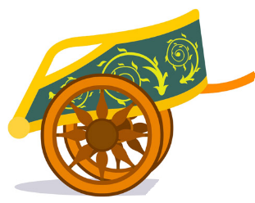  Task: Research Ancient Greek modes of transport.  Why not have a go at making your own model chariot? | Were the Ancient Greek Olympics similar to those that take place today?  Task: Carry out some research about the Ancient Greek Olympics. The links below will help you with this.  List five differences between the ancient and modern games.  https://www.bbc.co.uk/bitesize/topics/z87tn39/articles/z36j7ty  https://www.bbc.co.uk/news/magazine-18611638 | Are you as fit as an Ancient Greek Olympian?  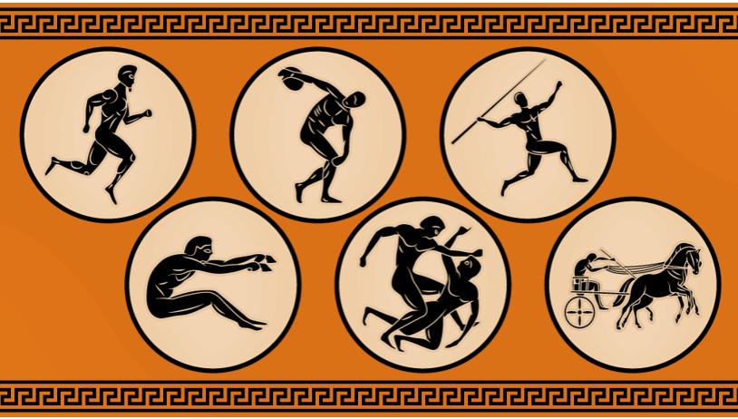  Task: Recreate some of the Ancient Greek Olympic events (you can be as inventive as you want to be with this, but no actual boxing please)!
What did the Ancient Greeks believe?  The ancient Greeks believed in many different gods and goddesses.  Each week you will be asked to carry out some research about one of them.  God of the Week: Poseidon  Task: Create a fact file based on what you have found out about this well-known god. | How do you say…in Greek?  Task: Find out how to say the following in Greek…  Hello/Goodbye –  Good morning –  Good evening -  How are you? –  My name is –  Please –  Thank you –  Yes –  No –  Excuse me -  https://medexperience.com/blog/basic-greek-phrases | Useful Websites  https://www.researchify.co.uk/  https://www.historyforkids.net/ancient-greece.html/  https://greece.mrdonn.org/  http://www.primaryhomeworkhelp.co.uk/Greece.html  https://www.ducksters.com/history/ancient_greece.php  https://www.bbc.co.uk/bitesize/topics/zkd9bdm  https://www.natgeokids.com/uk/discover/history/greece/10-facts-about-the-ancient-greeks/  https://www.dkfindout.com/uk/history/ancient-greece/

