Tuesday 14.07.2020
Fluent in Five  - 1,121 – 976 =  - 2.4 – 1.6 =  - 61 x 100 =  - 831 ÷ 3 =  - 2 x 9 x 7 = | Word Problem  On Sunday I spent 98 minutes on my art project, and 35 minutes on my numeracy homework.  On Thursday evening I spent a total of 100 minutes on my homework.  What is the difference between the amount of homework I did on Sunday and Thursday evening?
Explain it  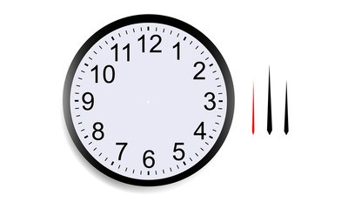  Karen says it is closer to 9 o’clock than 10 o’clock.  Do you agree? Explain our answer. | Challenge  Continue these sequences in Roman Numerals by writing the next 4 numbers in each sequence.  XXII, XXIV, XXVI, XXVIII _________________  XLV, LIV, LXIII, LXXII_____________________

Answers
Fluent in Five  - 1,121 – 976 = 145  - 2.4 – 1.6 = 0.8  - 61 x 100 = 6100  - 831 ÷ 3 =277  - 2 x 9 x 7 = 126 | Word Problem  On Sunday I spent 98 minutes on my art project, and 35 minutes on my numeracy homework.  On Thursday evening I spent a total of 100 minutes on my homework.  What is the difference between the amount of homework I did on Sunday and Thursday evening?  98 + 35 = 133  133-100 = 33  So I did 33 minutes more on Sunday
Explain it  Karen says it is closer to 9 o’clock than 10 o’clock.  Do you agree? Explain our answer.  I agree, it is 25 minutes past 9 so 35 minutes away from 10. | Challenge  Continue these sequences in Roman Numerals by writing the next 4 numbers in each sequence.  XXII, XXIV, XXVI, XXVIII, XXX, XXXII, XXXIV, XXXVI  XLV, LIV, LXIII, LXXII, LXXXI, XC, XCIX, CVIII

