Friday 17.07.2020
Fluent in Five  - 2,099 - 100 =  - 10 x 4 x 12 =  - 41 x 31 =  - 100 x ___ = 267  - 147 ÷ 3 = | Word Problem  Sally bought 3 photograph frames, each costing £2.50. She paid with £20.00. How much change did she get?
Explain it  George has three silver coins.  What could the total amount be?  How many different amounts can you make? Explain your answer. | Challenge  You must choose four different digits from 1−9 and put one in each box. For example:  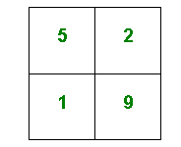  This gives four two-digit numbers:  52 (reading along the 1st row)  19 (reading along the 2nd row)  51 (reading down the left hand column)  29 (reading down the right hand column)  In this case their sum is 151.  Try a few examples of your own.  Is there a quick way to tell if the total is going to be even or odd?  Your challenge is to find four different digits that give four two-digit numbers which add to a total of 100.  How many ways can you find of doing it?

