Friday 26.06.2020
Arithmetic

- 8,974 + 100 =
- 274 + 347 =
- 2,807 – 2,089 =
- 6 x 5 x 10 =
- 3.9 + 7.2 =
- 656 ÷ 8 =
- $\frac{7}{11}$ of 88 =
- 10 x ___ = 27
- 6 x 3 =
- 9 x 9 =
Times Table Rockstars
Spend 10 minutes on TT Rockstars (ON SOUNDCHECK PLEASE!)
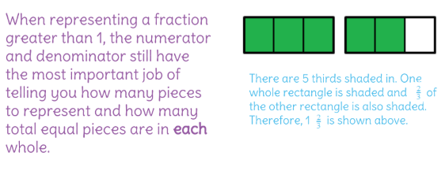
Maths Task – Fractions Greater Than 1

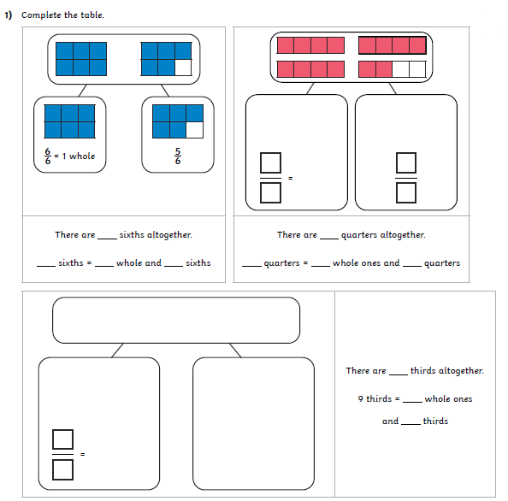

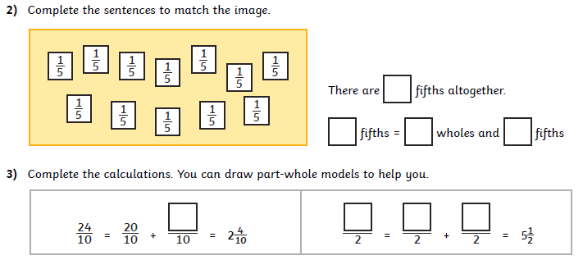

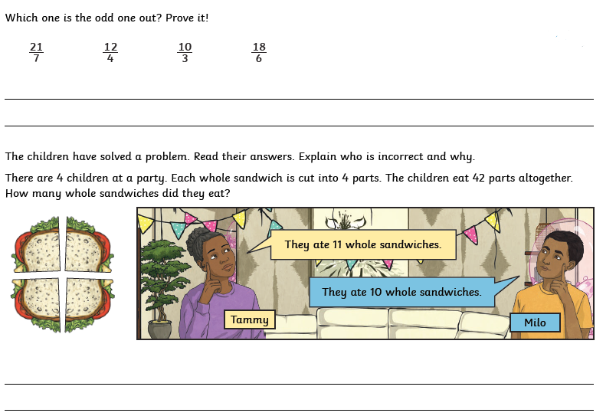
4)

5)

