Tuesday 16.06.2020
Fluent in Five
- 2.7 – 1.8 =
- 5,016 – 2,874 =
- 9 x 2 x 8 =
- 8 x 10 x 5 =
- 366 ÷ 6 =
Times Table Rockstars
Spend 10 minutes on TT Rockstars (ON SOUNDCHECK PLEASE!)
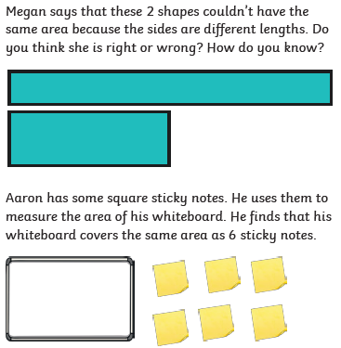
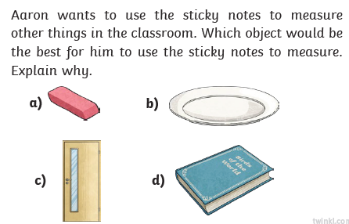
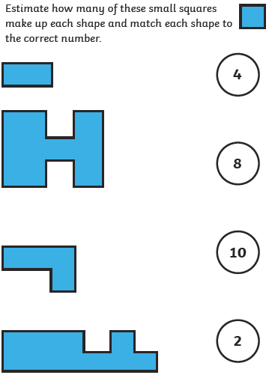
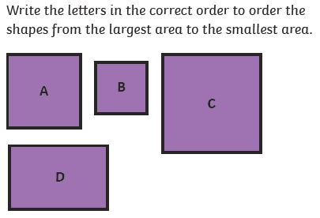
Maths Task – What is area?
3)
1)
2)
4)

