Friday 15.05.2020
Arithmetic
- 479 – 100 =  - 72 + 200 =  - 624 – 30 =  - 64 ÷ 4 =  - 2788 + 3417 = | - 8291 – 73 =  - 9 x 5 =  - 9 x 2 x 4 =  - 352 x 3 =  - 3.54 + 0.09 =
Times Table Rockstars
Spend 10 minutes on TT Rockstars (ON SOUNDCHECK PLEASE!)
Maths Task
We’re spending some ore time working on the 6 times table today – looking at the multiplication and division facts.
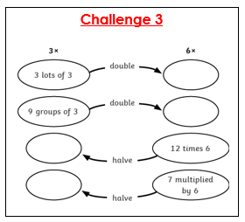
Write out your 6x tables again and then your 3x tables. What do you notice?
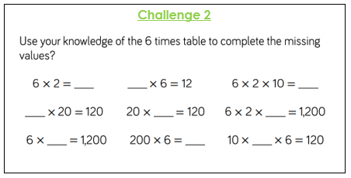
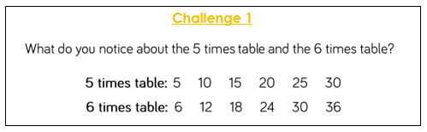
Challenge 4

Read each statement. Are they true or false? Explain why.

