Monday 08.06.2020
Fluent in Five
- 10 x 0.84 =
- 20 x ___ =200
- 4 x __ = 4
- 12 x 46 =
- 60 ÷ 5 =
Times Table Rockstars
Spend 10 minutes on TT Rockstars (ON SOUNDCHECK PLEASE!)
Maths Task – Multiplying 2-digit numbers by 1-digit numbers
There are 3 main methods we use for multiplication. Remind yourself how each one works by looking at the examples below.
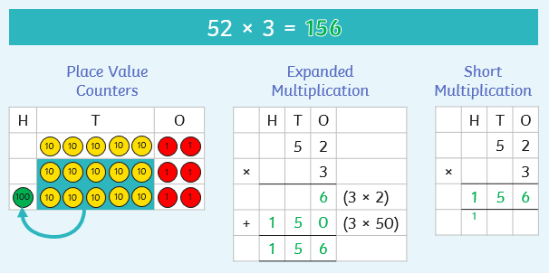
Now complete the missing parts to show how to use each method of multiplication in the examples below.

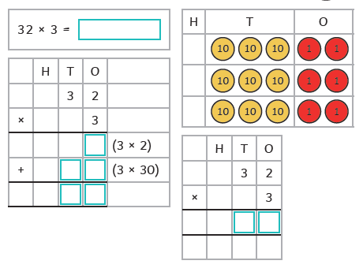
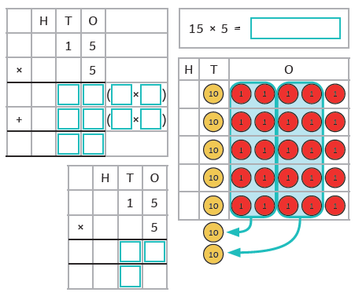
1)
2)
3)

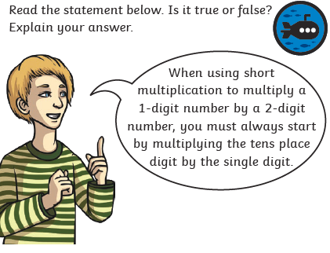
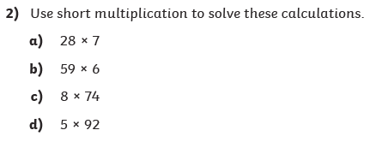
4)
3)

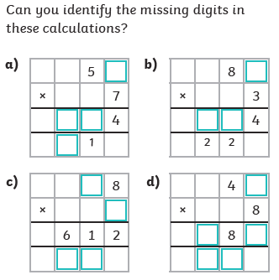
5)

