Wednesday 01.07.2020
Fluent in Five
- 874 + 200 =
- 29 x 3 =
- 41 ÷ 3 =
- 1,087 – 100 =
- 7 x 3 x 2 =
Times Table Rockstars
Spend 10 minutes on TT Rockstars (ON SOUNDCHECK PLEASE!)
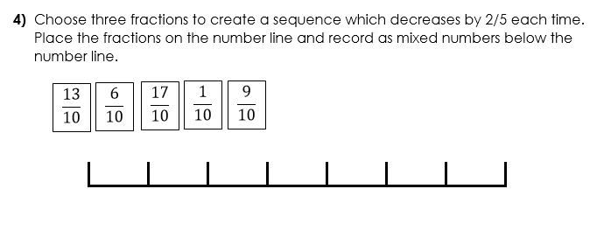
Maths Task – Counting in Fractions
