Dear Parents/Carers,
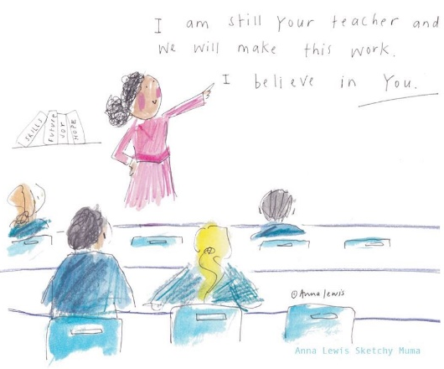
Welcome back to remote learning! We hope that you are safe and well; we recognise how challenging this time is, and the impact it will have on everyone’s wellbeing. It is vital that children are accessing the learning opportunities we are providing through teams to support their progress, these can be accessed at any point, allowing you to tailor learning around your day in a way that works best for you and your family. Creating structure and routine is essential in these uncertain times, however, we understand that it is difficult to juggle life responsibilities with remote learning. To support this we ensure the lessons guide children using formats and structures they are familiar with (in school) each day, allowing them to complete the work independently.
Thank you for your hard work and co-operation with the remote learning, please remember that although we are not in the same room, we are still your child’s teachers and are happy to help in any way. Do not hesitate to get in touch with us with your questions, concerns or for a catch up with the children.
Our expectation is that children will:
- Watch the English and maths teaching videos each day, and use these to help them complete the corresponding tasks.
- Spend at least one hour on each subject. This does not have to be as one block, it can be broken up as we appreciate that everybody’s situation is different, so you will need to find a routine that works for you. Spending an hour on each subject will allow children to complete all work set that day to the best of their ability:
- Maths (fluent in five, maths recall & lesson content)
- English (lesson content & spelling activity)
- Topic (one task from the grid each day)
- Complete tasks with neat presentation. We ensure that the work we set can be adapted to a method that suits you- this might be pencil and paper, printed files or working straight onto documents. The topic tasks have also been designed with this in mind, allowing you to be flexible with how the work is presented; we encourage the children to be creative with this.
- Submit work to their teacher each day, either by uploading it to teams or via email, so that we can provide helpful feedback. This can be documents, or photos of written work.
- Access Times Table Rock Stars to practice their times tables.
- Read regularly (at least 3 times a week) using the books they have been allocated on the Rising Stars website. Miss Goodwin has also provided some links to free online reading resources and games on the school website https://birklandsschool.co.uk/page.php?d=year3&p=reading
- Contact their teacher via teams or email with any questions or if they need help from us.
In return we will:
- Upload maths and English video lessons each day to support the children’s tasks, and provide resources to guide you through the topic tasks each week.
- Maintain regular contact with you and your child (via email, phone calls and teams) to support with home learning, wellbeing and any concerns you may have. We are here to help you with any questions, and will be available between 8.30am- 4pm.
- Provide daily feedback in response to the work submitted to ensure your child has understood the objectives. Any work submitted after 4pm will be followed up the next day.
We are grateful for your continued support, communication and understanding- thank you.
Miss Goodwin & Miss Marsh

