The Ancient Olympics
Did you know the first Olympic Games were held in 776BC which is over 2700 years ago? Interestingly the games were held in Elias near Olympia. Amazingly the Olympic Games were part of a religious festival to honour Zeus the king of Greek Gods. The Olympic Games were held every four years.

Who took part in the Olympic Games?
Only men, boys and unmarried women were allowed to participate in the Olympic Games. However there was a separate women’s festival to honour Hera (zeus’ wife). Did you know that all athletes had to do the games naked to show off their physique?

What events took place in the Olympic Games?
Many events that took place at the Olympics. There was running, javelin, horse racing, discus, long jump and pankration. Do you know that running was the first event to take place at the Olympics?

Do the Olympics still happen today?
Interestingly the Olympic Games still happen today and are still held every four years. We still have some of the old events like running, javelin, long jump and discuss.

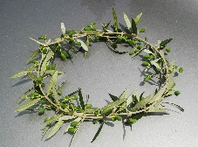
Winners of the Olympics
Some competitors were successful in winning their events in the ancient Olympics and they received a crown of olive branches and a banquet. Today winners of the Olympics receive medals and a bouquet of flowers.

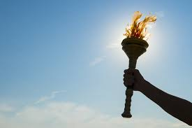
Symbols of the Olympics
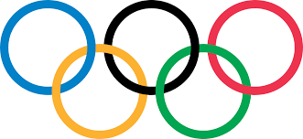
In the ancient Olympic Games and today they light the Olympic Flame at the opening ceremony of the Olympic Games. The flame then continues to burn in the cauldron for the duration of the Games, until it is extinguished during the Olympic closing ceremony. The Olympic flag has a white background, with five interlaced rings in the centre: blue, yellow, black, green and red. This represents the five continents of the world and was first used at the 1920 Olympics.

