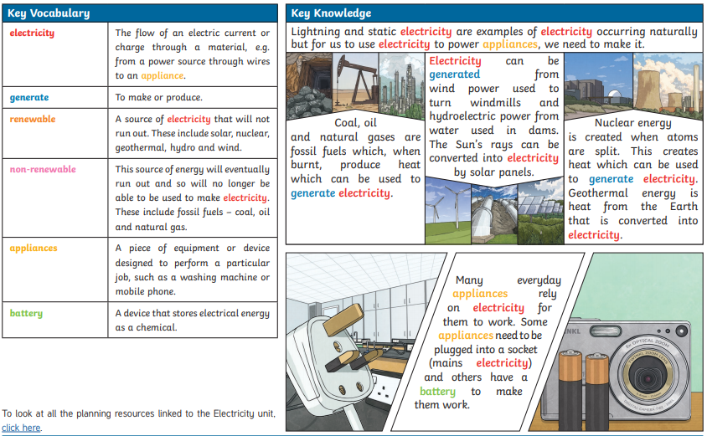

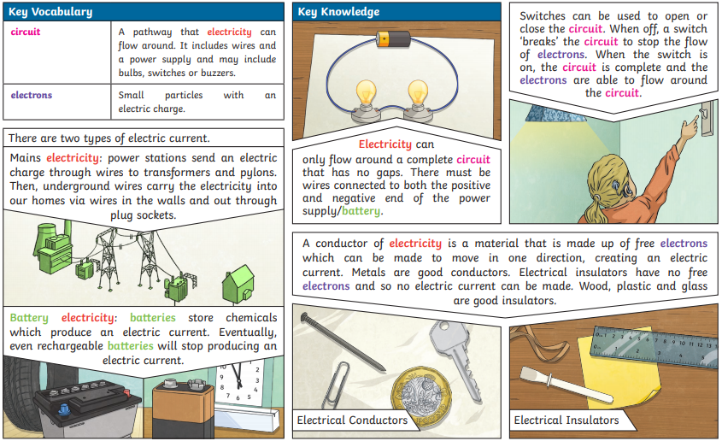

Week One
Our science theme for the next two weeks will focus on exploring electricity. Some tasks will take longer than others, so feel free to complete these over several days if needs be. You may do these in any order that you wish, and present your work in a way that suits you- be creative!
What are the dangers of electricity?  Use the resources below and your own research to find out about the dangers of electricity:  - http://www.switchedonkids.org.uk/electrical-safety-in-your-home  - https://www.bbc.co.uk/bitesize/clips/zyxd7ty  Task: Create a safety poster/ video highlighting the dangers of electricity. | How do we use electricity in our home?  Electricity is central to modern day life. 150 years ago, people lived without any electricity. Do you think you could manage without electricity for a day?  Task: Complete a ‘log’ to track how you use electricity in a day e.g. switched on lights, played xbox. Now decide whether each use was essential or not.  There is an ‘essential and non-essential uses of electricity’ sheet attached that you could use. | Electricity inventors  Use the resources below and your own research to find out about two pioneers in electricity.  Thomas Edison:  - https://www.ducksters.com/biography/thomas_edison.php  - https://www.youtube.com/watch?v=KgSi_R1Wcyk  Benjamin Franklin:  - https://kids.kiddle.co/Benjamin_Franklin  - https://www.youtube.com/watch?v=nOF0OCI1xIc  Task: Choose one of the inventors and create a fact file/ biography about their life and inventions.
Electrical circuits  Watch the video below to find out about electrical circuits.  - https://www.youtube.com/watch?time_continue=3&v=KYKVf6edvcA&feature=emb_logo  Task: Put your knowledge to the test and see if you can match the symbols to the names!  The quiz is attached at the end of this document | Design your own electrical circuit  Draw each of these circuits using the scientific symbols for each component:  - A circuit with a bulb, a cell and an open switch  - A circuit with a battery and two motors  - A circuit with a buzzer, two batteries and a closed switch  - Design your own!
Week Two
Our science theme for the next two weeks will focus on exploring electricity. Some tasks will take longer than others, so feel free to complete these over several days if needs be. You may do these in any order that you wish, and present your work in a way that suits you- be creative!
Electrical conductors/ insulators  Task: Choose different materials and predict if you think they are electrical insulators or conductors.  Then have a look at these resources or do your own research to see if you were correct.  - https://www.bbc.co.uk/bitesize/topics/z2882hv/articles/zxv482p  - https://www.youtube.com/watch?time_continue=219&v=3Wl-5w1yCh4&feature=emb_title  - https://www.thoughtco.com/examples-of-electrical-conductors-and-insulators-608315 | Static Electricity  Static electricity is a naturally occurring type of electricity. It is usually caused by friction. Have you ever got a shock from touching a door handle? That’s caused by static electricity!  Task: See if you can carry out any of these experiments using static electricity at home.  https://www.youtube.com/watch?v=ViZNgU-Yt-Y | Electricity inventors  Use the resources below and your own research to find out about two pioneers in electricity.  John Logie Baird:  - https://www.coolkidfacts.com/john-logie-baird/  - https://www.youtube.com/watch?v=ZC0YZOXmvKs  Hertha Ayrton:  - https://www.youtube.com/watch?v=0LjZ6RcaHYI  - https://www.youtube.com/watch?v=Kc3VmGNnKng  Task: Choose one of the inventors and create a fact file/ biography about their life and inventions.
Fun Facts!  - Electricity travels at the speed of light, about 300,000 kilometres per second.  - A typical microwave uses more electricity powering its digital clock than it does heating food  - The word “electrocute” is a combination of the words electro and execute, meaning you were killed by electricity. So, if you don’t die, you were not electrocuted, only shocked.  Task: Find some more fascinating electricity facts! | Electricity inventors  Electricity is constantly developing; our lives are becoming more electrical. But, today you are going to invent an electrical item that doesn’t yet exist.  Task: Invent a machine that could do anything- it could turn clouds to ice-cream or be a pair of shoes that play music as you walk. Think outside of the box.  You could draw it or write about it, or both. Tell me what it does, how it works and the materials it is made from. Happy inventing!
