Wednesday 24.06.2020
Fluent in Five
- 10,978 - ___ = 5,798
- 7 x 6 =
- 8 x 9 =
- $\frac{3}{7}$ of 28 =
- 6 x 7 x 2 =
Times Table Rockstars
Spend 10 minutes on TT Rockstars (ON SOUNDCHECK PLEASE!)
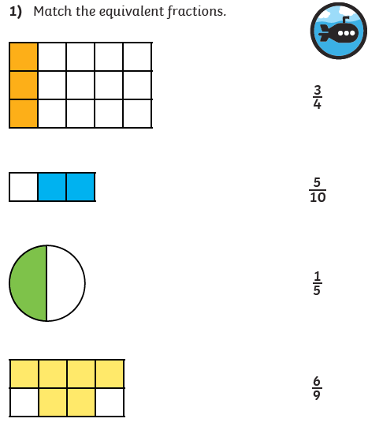
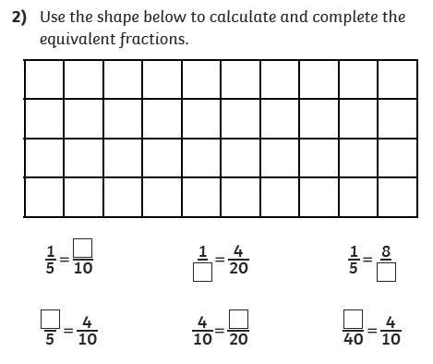
Maths Task – Equivalent Fractions

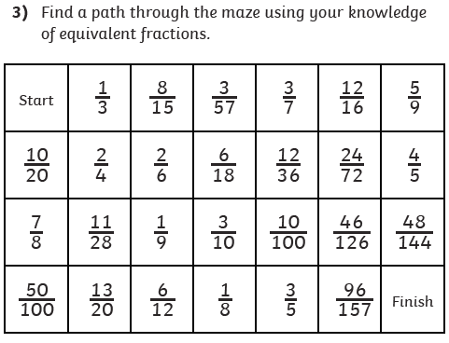

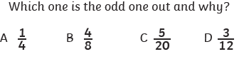
4)

