**Wednesday 24.06**

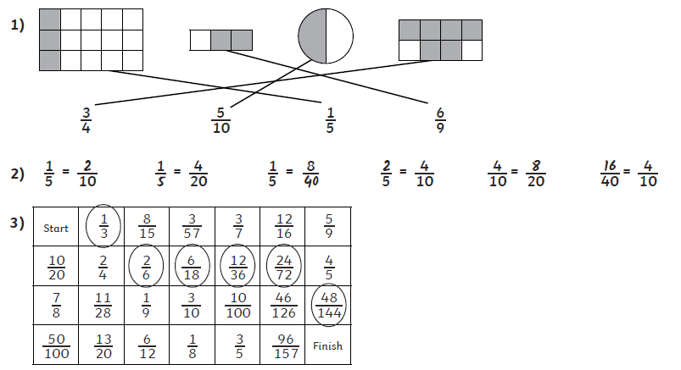

**4)**

