Tuesday 23.06.2020
Fluent in Five
- 605 + 3,987 =
- 874 – 474 =
- 100 x 0.8 =
- 12 x 3 =
- 0.9 + 10.8 =
Times Table Rockstars
Spend 10 minutes on TT Rockstars (ON SOUNDCHECK PLEASE!)
Maths Task – Equivalent Fractions
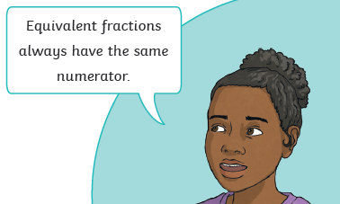
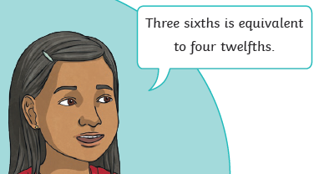
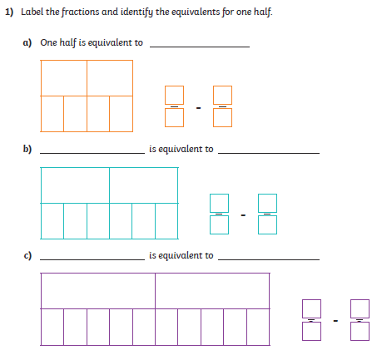
Remember you can look at the fraction wall on your knowledge organiser to help you find equivalent fractions.
2) Do you agree? Explain your answer.

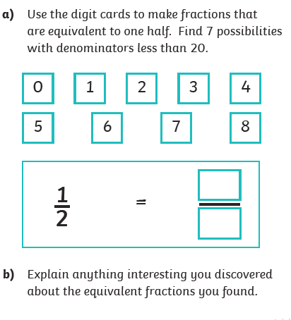
4)

