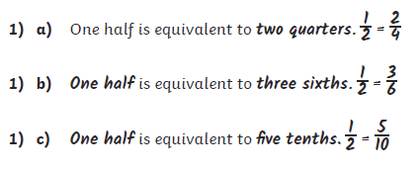**Tuesday 23.06**

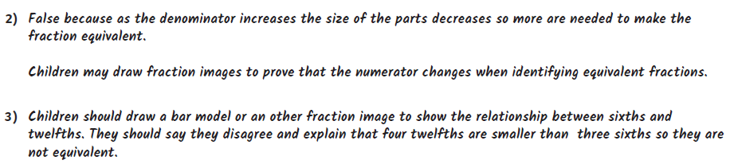



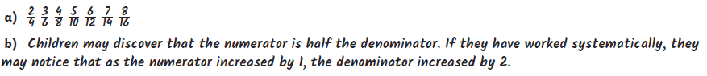

**4)**