Thursday 18.06.2020
Fluent in Five
- 16 ÷ 4 =
- 8 x 7 =
- 12 x 4 =
- $\frac{6}{7}$ of 21=
- 100 x ___ = 54
Times Table Rockstars
Spend 10 minutes on TT Rockstars (ON SOUNDCHECK PLEASE!)
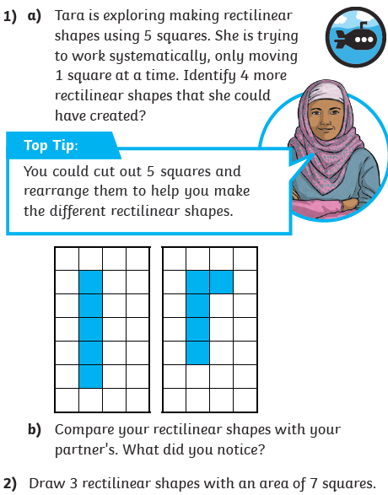
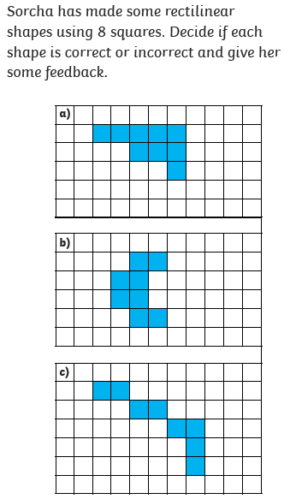
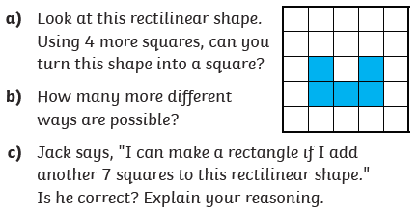
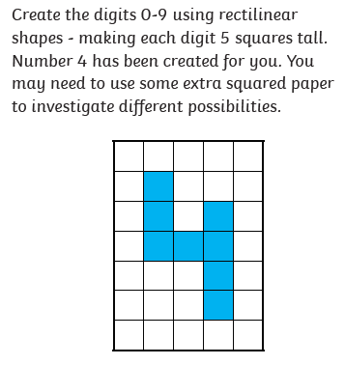
Maths Task – Making Shapes
3)
4)
Calculate the area of each number. Which is the largest? Which is the smallest? Make a 3 digit number with an area of 19. How many possibilities are there?
5)

