Tuesday 12.05.2020
Fluent in Five
- 2,807 + ____ = 4,000
- 999 – 50 =
- 57 x 100 =
- 57 x 10 =
- 890 ÷ 100 =
Times Table Rockstars
Spend 10 minutes on TT Rockstars (ON SOUNDCHECK PLEASE!)
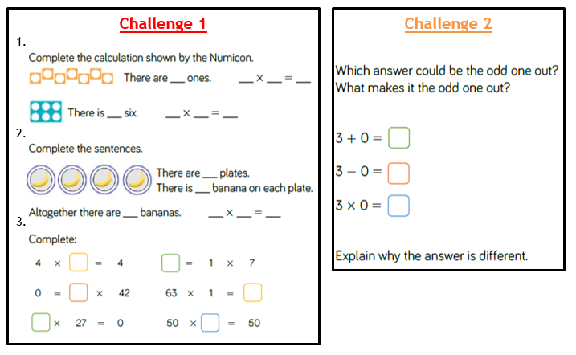
Maths Task
Today we are looking at multiplying numbers by 1 and 0.
REMEMBER!
Multiplying a number by 1 means you have one lot of that number, so the answer is the same as the number you are multiplying by 1. For example:
7 x 1 = 7
1 x 12 = 12
Any number multiplied by 0 is 0.
2 x 0 = 0
0 x 9 = 0

