Monday 01.06.2020
Fluent in Five
- 2,818 + 1,097 =
- 2,000 - 897 =
- 9 x 5 x 4 =
- 12 x ___ = 144
- $\frac{2}{6}$ of 54 =
Times Table Rockstars
Spend 10 minutes on TT Rockstars (ON SOUNDCHECK PLEASE!)
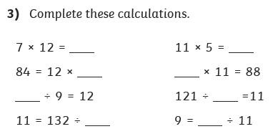
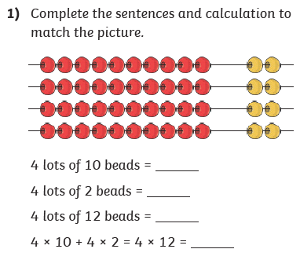
Maths Task - 11 and 12 x tables
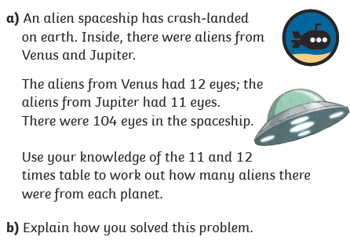
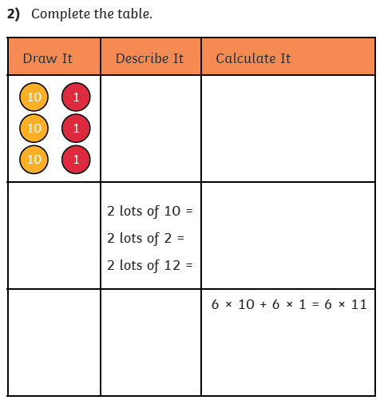
5)
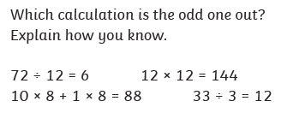
4)

