Key Stage One Newsletter
Autumn Term 2022
Welcome to the KS1 Newsletter for the Autumn Term 2022. We are excited to be starting a new academic year of fun and challenging learning with all the children in Jay, Dove and Magpie classes.
PE
PE days will be as follows….
Magpie – Wednesday & Friday
Dove – Monday & Friday
Jay – Tuesday & Friday
Please note the change to PE days for Jay and Dove classes. Children should come to school in PE kit and stay in it all day. Please ensure any earrings are removed.
School Dinner
All children in Year 1 and Year 2 are entitled to receive universal free school meals. Not only will you be saving money, but you will also be giving your child a nutritionally-balanced meal to fuel their bodies for the rest of their learning day. We do not need advance notice, children can just say on the day.
Uniform
All children should be in the correct uniform every day. On PE days, children should wear Birklands PE kit and are not allowed to wear alternative clothing.
PLEASE mark your child’s name in their clothing – we end up with numerous jumpers which go unclaimed. A name on the tag easily prevents this.
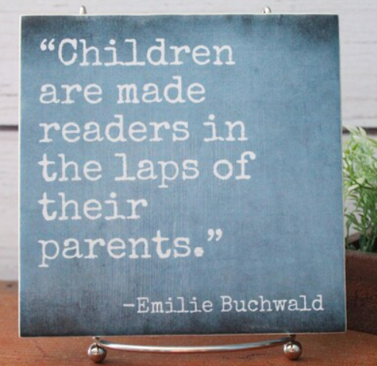
Children who read at home for just 10 minutes a day make great progress.
Your child is at a crucial stage in their journey to becoming a reader. Please read with them.

100 books – HELP!
We are currently missing dozens of books which were loaned to children as part of our ‘100 books to read’ scheme.
We urgently need any books sending back into school. Please look around at home to see if you can find any that have not been returned and send back ASAP!

Milk
Every child is entitled to milk each day at a subsidised price of around £14 a term. They must be registered in order to receive milk. You can register and pay online at www.coolmilk.com

Reading…
All children will receive a reading book and diary. Children are encouraged to read at home every day with adult support. It is very beneficial for children to reread the same book to develop fluency and confidence. Books will be changed weekly. Please write in your child’s reading diary every time they read.

Who’s who?

Magpie Class: Mrs Henderson & Mrs Norman
Dove Class – Mrs Lewis
Jay Class – Miss Marsh
The teaching assistant supporting learning within Key Stage One is Mrs Sefton.
We are here to help – please just ask!

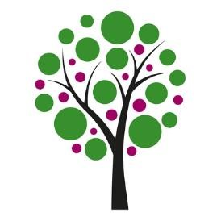
Y1 & 2 Overview of learning
Autumn two
Here is an overview of our Learning Objectives for this half term. If you have any queries please contact Mrs Henderson, Mrs Norman, Mrs Lewis or Miss Marsh.
Maths: Addition and subtraction, shape.  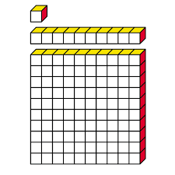  Moving on from our learning in place value and number, we will spend most of this half term focussing on addition and subtraction. By approaching the maths in small steps, we are able to ensure the learning builds on previous knowlegse and meets all learners needs.  After addition and subtraction, we will move on to shape. During this unit, we will explore 2d and 3d shapes and their properties.  The learning intentions in year two will build on from the year one objectives, ensuring challenge for all. | English  Our English books link closely to our topics. This half term, we will be focussing on ‘Only One You’, linking closely to our RE topic. We will then explore ‘The Bear who Stared’ and ‘The Squirrels who Squabbled’. We will be using these books to write a character description of our own. Finally, we will be focussing on ‘Chanukah Lights Everywhere’, linked to our RE topic of Celebrations and festivals.  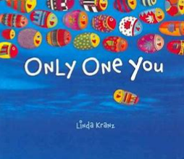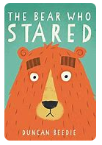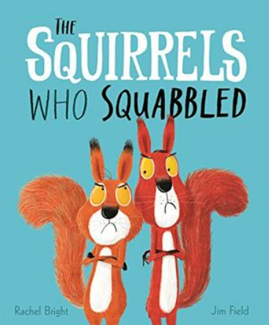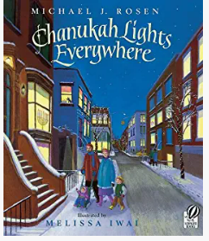
Science: Animals including humans and seasons.  During this topic, we will explore the five common vertebrate groups. We will learn about what animals eat and how to group them accordingly, life cycles and basic body parts.  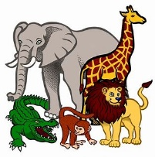  When learning about seasons, children will learn about the four seasons, describe weather associated with seasons and recognise that daylight hours change according to the season. | RE:  ‘Myself and Caring for Others’  ‘Celebrations and festivals’  During the unit, Myself and caring for others, we will be thinking about how we show each other that we care. We will also consider why it matters to show people that we care.  During the unit, Celebrations and festivals, we will explore which religions celebrate different festivals and why these celebrations are important to them.
DT:  This half term, we will be focussing on structures and mechanisms, linked to our learning in science. Children will be using their learning on mechanisms and structures to make a finished product. | PE:  This half term, we will be working on multi-skills and gymnastics. Building on the learning that children have previously done in PE.  