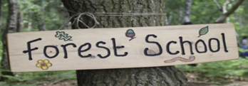

Woodpecker Class your forest school adventure begins in Autumn term!

Dear Parents/ Carers,

Forest School will run on Tuesday afternoons, starting Tuesday 19th September.

Please note these sessions will run outside in all-weather so please be ready with appropriate clothing (be prepared for these clothes to get dirty!)—waterproof coat/ trousers, wellies/ boots, warm garden clothes, hats, scarves and gloves, long sleeves and long trousers are essential.

These sessions will encourage the children to explore the world around us and develop their own physical awareness as well as ability to work as part of a team.

Children should attend school in their normal school uniform and will change in the afternoon. Please provide children with forest school clothing and shoes in a named bag.

Let our adventures begin!

Thanks,
Miss Fox

